**RAM Scientific Calculator**

**User Guide**

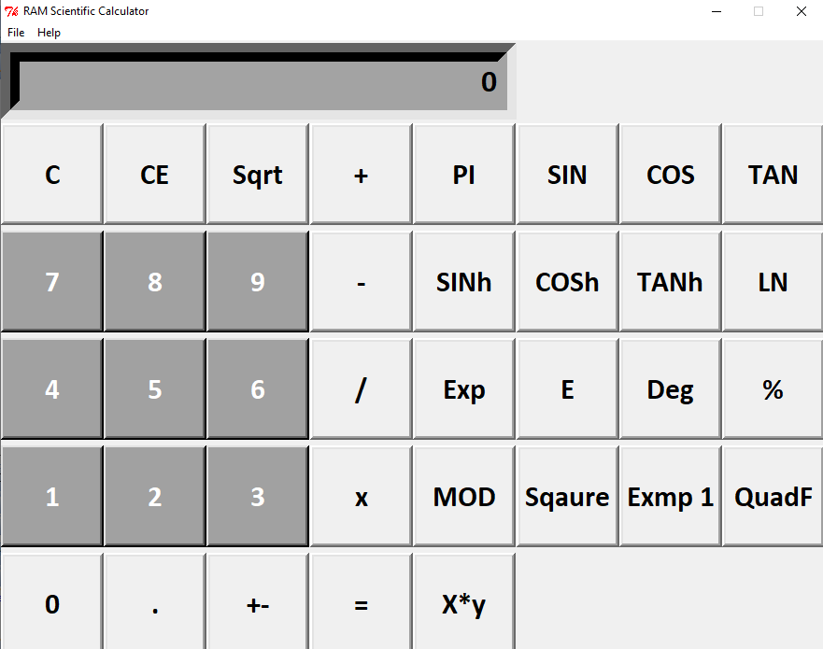

**GUI Components:**

**Welcome and Starting Screen:**

**Main Number Pad:**

This is the main number pad of the application. By pressing the number keys, you can enter the corresponding values or integers into your calculator.

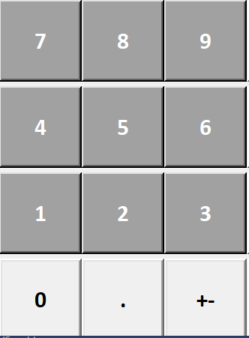

**Basic Mathematical Operators:**

**Addition – Used to add numbers:**

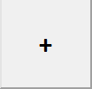

**Subtraction – Used to Subtract Numbers:**

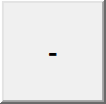

**Multiplication – Used to Multiply Numbers:**

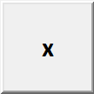

**Division – Used to Divide Numbers:**



**Decimal Point – Used to create decimals:**



**Plus/Minus Inverse – Used to inverse the sign of a number:**

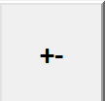

**Equal Sign – Press to see the answer on screen:**

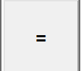

**Square Root – Used to Square root a number:**

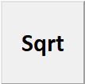

**Percentage – Used to easily find the decimal of a number**



**Exponent – Used to apply a number to a power:**

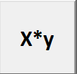

**Square – Used to find the square of a number:**



**Complex Mathematical Operators:**

**Sin – To use the trigonometric function Sin:**

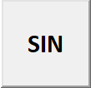

**Cos – To use the trigonometric function Cos:**

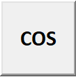

**Tan – To use the trigonometric function Tan:**

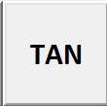

**Sinh – To use the hyperbolic sine function:**

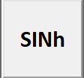

**Cosh – To use the hyperbolic cos function:**

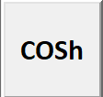

**Tanh – To use the hyperbolic tan function:**



**Pi – To use the mathematical constant Pi (3.14):**

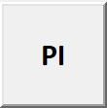

**Exp - calculates the value of e to the power of x**



**E – The Base of natural logarithms:**

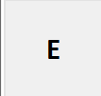

**Deg – To convert a number to degrees:**



**MOD – Gives the remainder when dividing:**



**LN - Natural Logarithm:**



**Exmp 1 – Calculates the exponential of all input array elements:**

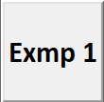

**QuadF – Helps the user calculate a quadratic formula by entering the corresponding values**



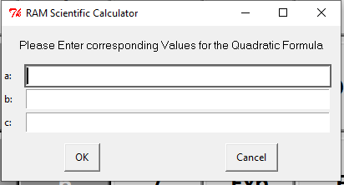

**Productive Operators:**

**Clear Button - Clears or removes the number on the screen:**

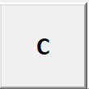

**All Clear Button – Clears your entire number history:**

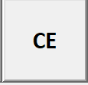

**Exiting and More Information:**

**About the Application:**

In order to gain more information about the calculator, proceed to the help menu above and select about.

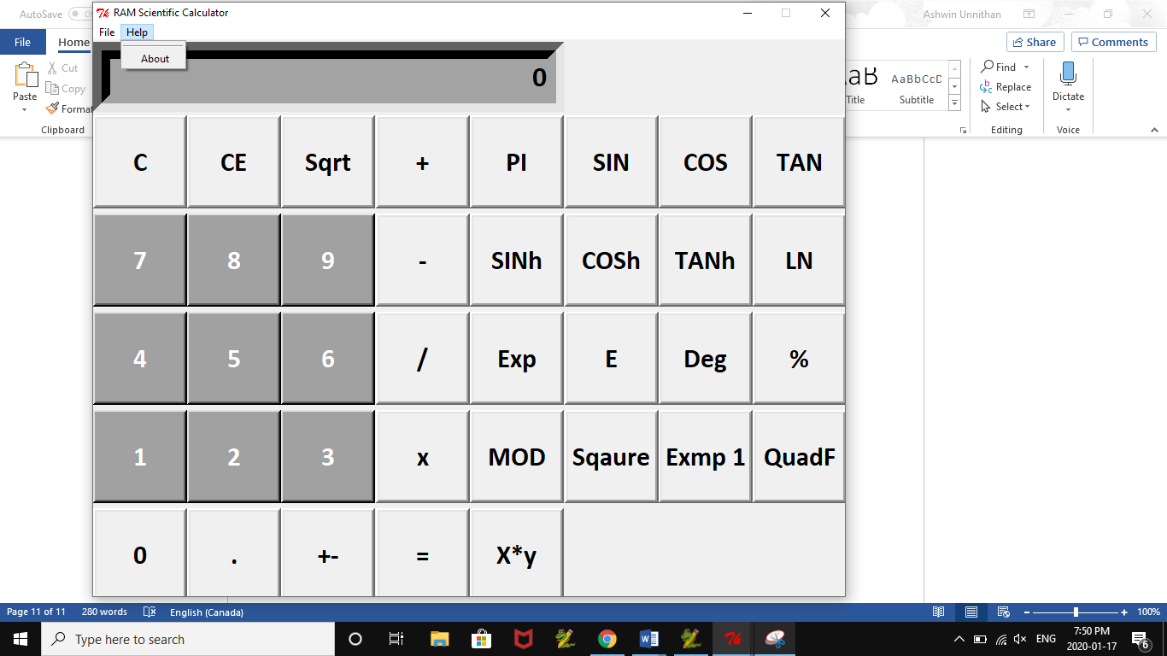

**Exit Application:**

In order to exit the application, simply select exit from the file menu or press the x icon located at the top right of the window.

